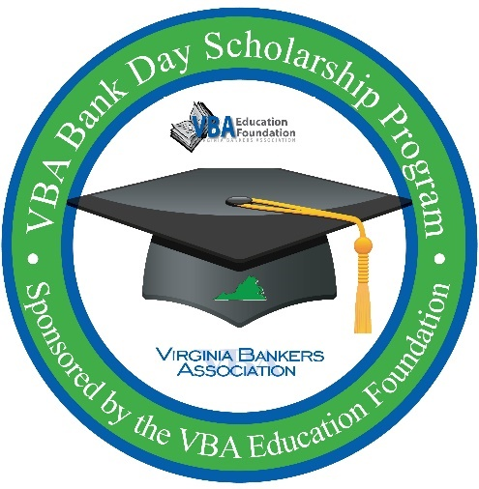**For Immediate Release**

**For More Information:**

[**Contact Name**

**Position   
Bank**

**Contact Phone Number & Email**]

**[Bank Name] to Host High School Seniors for VBA Bank Day Scholarship Program:**

**Students Will Participate for a Chance to Win Up to $7,500 in College Scholarships**

[**City, VA (Date)**] – On March **[specific date]**, **[bank name]** will host high school seniors from **[high school(s)]** to participate in Bank Day, a statewide effort sponsored by the Virginia Bankers Association (VBA) Education Foundation and the VBA Emerging Bank Leaders. The purpose of the program is to expose students to the banking industry and provide an opportunity for the students to learn about banking, careers in banking, financial services and the vital role [**bank name**] and banks across Virginia play in their communities.

The third Tuesday in March was declared Bank Day by the Virginia General Assembly in 1991 and [**bank name**] is proud to host students for this important program. From their experience, participating students will write an essay for the chance to win a scholarship. Six regional scholarships of $2,500 each will be awarded by the VBA, and from those six winners an overall statewide winner will be chosen. The statewide winner will receive an additional $5,000 scholarship - $7,500 in total. There will also be six honorable mention scholarships of $1,000 each. In all, twelve students statewide will receive scholarships totaling $26,000.

Throughout the program, students will have access to a Virginia banking industry resource website that houses videos, articles and podcasts to explore and research. **[As a Bank Day host, [[Bank Name]] will also be hosting students [[in-person/virtually]] on X date for a Bank Day gathering as well as providing supplemental information to students about ways the bank supports the community (or any other details about other supplemental opportunities you will be offering the students).]**

"Bank Day is one of the best short-term experiences for students—the opportunity to learn about the many services that banks offer and the ways Virginia banks support the communities they serve, and to start the networking that often leads to part-time and summer jobs, scholarships, and a start on a career path in the financial world,” said Bruce Whitehurst, president & CEO of the Virginia Bankers Association.

[**Optional quote from your bank’s President.**]

***About [bank name]***

*[Information]*

***About the VBA Education Foundation***

*The Virginia Bankers Association Education Foundation was formed in 2007 with the objective of recognizing the importance of economic education and financial literacy in Virginia and supporting the banking industry as a key participant in these areas. Their mission is to advance personal financial literacy to students in all public and private schools across the Commonwealth. Learn more about the VBA Education Foundation* [*here*](https://www.vabankers.org/education-foundation)*.*

###