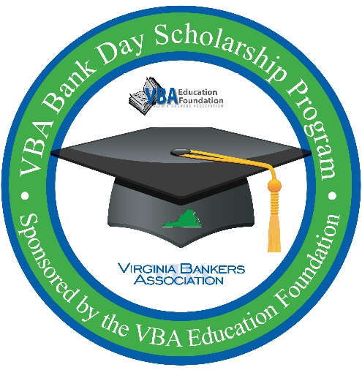
Good morning/afternoon!
Thank you for registering for the VBA Bank Day Scholarship Program. [Bank name] is excited to host you on [date] from [start time-finish time] for this exciting program.
Please be on the lookout for more details about the program from [bank name] as well as the Virginia Bankers Association in the coming weeks.
If your plans have changed and you are no longer able to attend Bank Day, please respond to this email to let me know as soon as possible.
If you have any questions about your registration or about the program, please feel free to let me know or reach out to Monica McDearmon at the Virginia Bankers Association at mmcdearmon@vabankers.org.
We look forward to meeting you in March!
Sincerely,
[Banker contact information]

