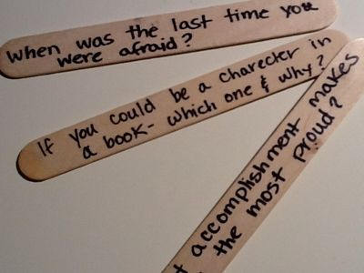**Sample Icebreaker Activities**

Create questions on popsicle sticks for students to select from a jar and answer. The same type of questions could be used for the dice activity (the sum of what they roll is the question number that they answer)!

Questions can be about anything OR banking specific. For example:

* I am proud of myself because…
* If I were invisible, I would…
* My favorite book is…
* My favorite store is…
* Do you have a savings account at a local bank?
* Have you ever visited a bank branch?
* What is something you’re saving your money for?
* For a hobby, I…
* If I could travel anywhere new I would go to…
* Make up your own question for the whole group!

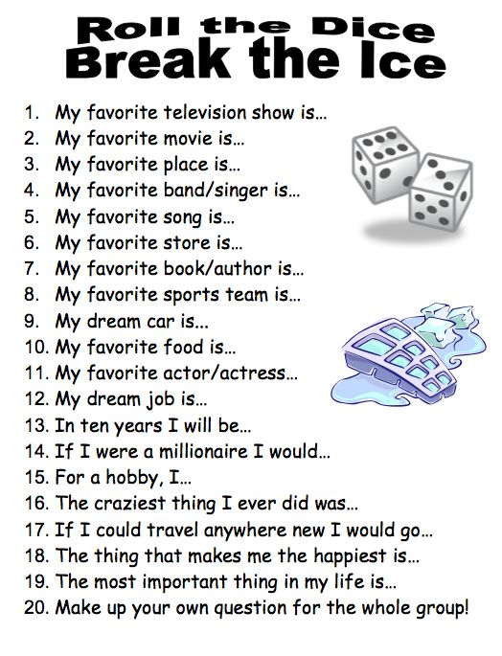

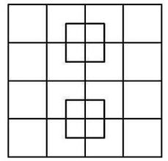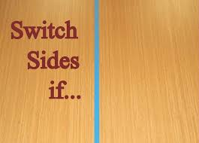

Put image up and ask students how many squares they can find. Give them time to think on their own, share with a partner and then share with the class. Circulate the room, but do not give them any hints or answers for a little while. Let them “struggle” a bit. You can start your hints by telling them “too high” or “too low”. Possibly reward the first person to get the right answer with either bank “swag” or approved candy/snack.  
**Answer: 40**

Create questions/statements about banking to guage prior knowledge. Start questions with the phrase “Switch sides if…” For example:

* Switch sides if you have a savings account.
* Switch sides if you’ve ever visited a bank branch.
* Switch sides if you know the difference between needs and wants. (then have one of them tell you the difference)
* Switch sides if you’ve ever saved your money to purchase something you wanted.
* Switch sides if you consider yourself a “spender”.
* Switch sides if you consider yourself a “saver”.

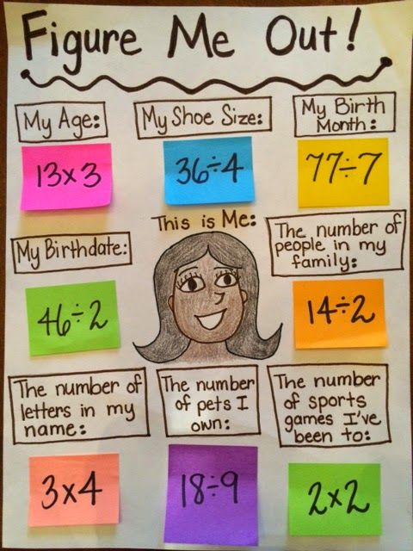

Presenter can create a poster about themselves for introduction. Possible information to include:

* My age
* My shoe size
* My birth month
* My birth date
* The number of people in my family
* How many years I’ve worked at my bank
* The number of letters in my name
* The number of pets I own
* The number of sports games I’ve been to